**Auto Marking Program Guideline**

**Things to do for OpenFlow Server Test**

1. Before you make a program, you consider a rules that we provide
   1. Below message type is sequence of Openflow message. You must be keep sending request message sequentially.
      1. HELLO : Responding about server connection attempts
      2. FEATURES_REQUEST: It is request to information about function of switch
      3. STATS_ REQUEST: It is request to information about statistical and status
      4. GET_CONFIG_REQUEST: It is informed to information about how to set of switch configuration.
      5. BARRIER_REQUEST: It is request to message about validation that command of controller
      6. STATS_ REQUEST: It is request to information about switch description
      7. ROLE_ REQUEST: It is request to information about role change (e.g : master->slave)
      8. PACKET_OUT: It is informed to information about how to activate of data packet

**What you can get in this project**

Today's network trend is changing to SDN. And OpenFlow protocol is representative In southbound of SDN. So if you do this test, you can to understand trend of network.

**List of grading items**

1. Openflow Server test (You keep the rule of openflow message flow)

Mission1: HELLO Message and Response about 'HELLO' sent from server

Mission2: FEATURES_REQUEST Response about ‘FEATURES_REPLY’ sent from server

Mission3: STATS_ REQUEST : Response about ‘STATS_REPLY’ sent from server

Mission4: GET_CONFIG_ REQUEST: Response about ‘GET_CONFIG_REPLY’ sent from server

Mission5: BARRIER_REQUEST: Response about ‘BARRIER_REPLY’ sent from server

Mission6: STATS_ REQUEST: Response about ‘STATS_REPLY’ sent from server

Mission7: ROLE_ REQUEST: Response about ‘ROLE_REPLY’ sent from server

Mission8: PACKET_OUT: Response about ‘PACKET_OUT’ sent from server

**How to test?**

1. Approach *166.104.143.225/index* through your web browser (Internet Explorer, Chrome, Firefox and etc.)

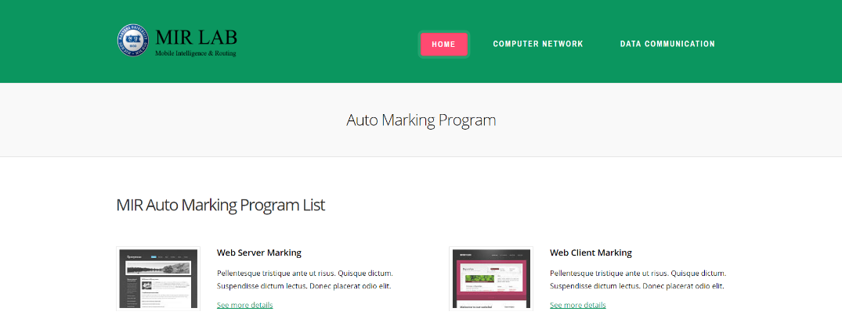

1. You have to choice in list association with your project

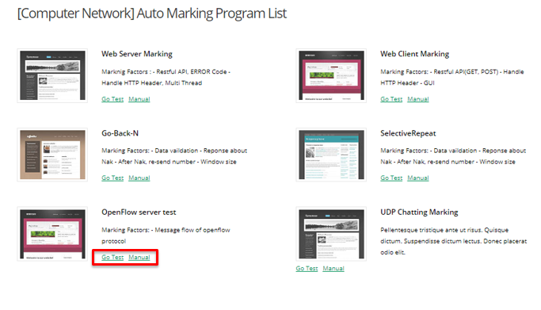

1. Fill out your information on blank.

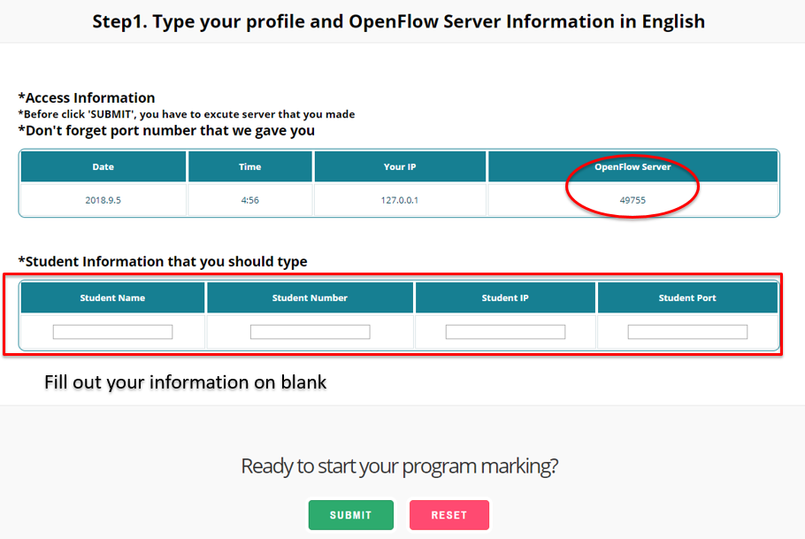

* + - * 1. Student Number(2017xxxxx)
        2. Student Name (Should be written in English)
        3. Your Web Server IP Address. If you are hard to find your global IP, refer to Current Connection Info in case you approaches this web site with the same computer
        4. Port that you assign for your Web server, Check this out on your Source Code
        5. You have to use this port number on your server program to setting for send to marking server.
        6. **Before click the submit button, you have to run your server and client.**

1. In this step, you check to mission that we provide before run your program

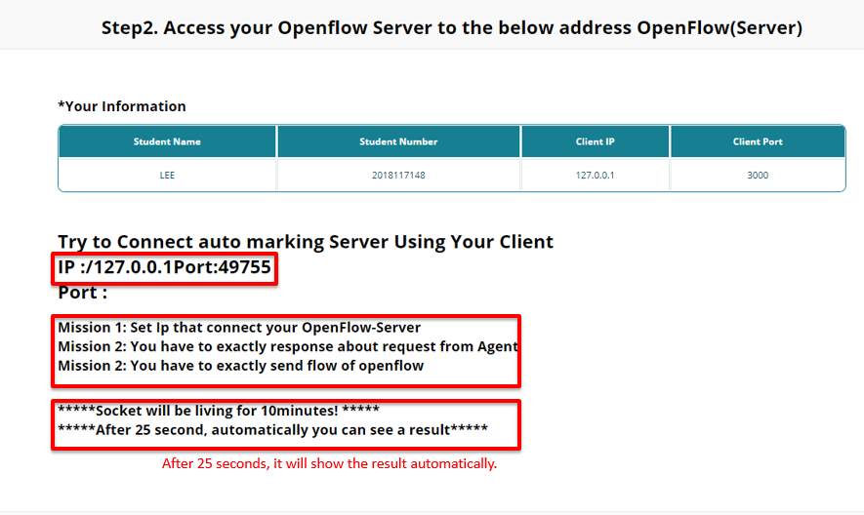

* + - * 1. You must be a think before run a your server of openflow

1. Before this step, you have to set IP and PORT we gave
2. After 25 second, your test will be a end
3. Socket that you use is a setting that end after 10minute. So after click submit button, for 10minute your test is must be a end.
4. Result Page

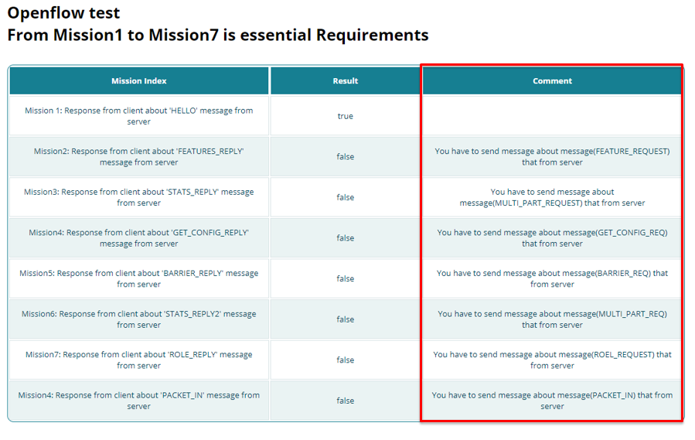

1. You can see what is wrong or correct with Reason
2. It will be stored our lab Database, based on this result we will grade your assignment.